# Package UML

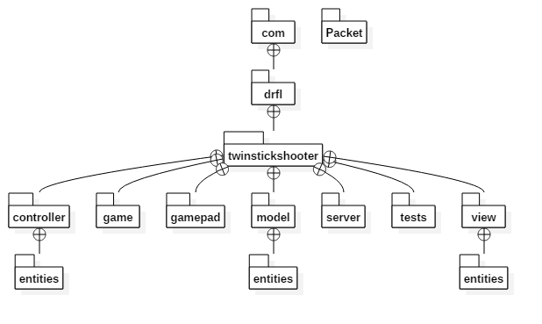

# Class Diagram UMLC:\Users\Francisco\Desktop\TSSGameClass.png

# Controller Class Diagram UML

# C:\Users\Francisco\Desktop\18195602_694541177384340_2075587170_o.png

# Architectural Pattern

### Model-view-controller

Used to separate concerns into modules so unit testing can be used with LibGDX. The Controller is supplemented by Box2D to manipulate the Model, where all data is stored. The View makes all the calls to OpenGL and creates the needed sprites to display the game.

# Design Patterns

### Singleton

Both TSSController and TSSModel use this pattern to guarantee only one instance of each is running at a time. This facilitates MVC usage.

Classes: TSSModel, TSSController

### State

State machine pattern is used to control current game screen.

Classes: TSSState

### Adapter

Adapter pattern is used to create the scoreboard of top 10 high scores. Each row is created from getting the 3 values that compose a TSSScore object, as such to avoid repeating the same lines of code for each kind of getter for that object, 3 subclasses that implement an interface are used so that an array of that interface can be used to call different getters according to the current index on a for loop.

Classes: TSSScoreboard